**What are the top 5 most popular genres?**

The goal of the code is to find the top 5 most popular game genres from a dataset.

1. **Understanding Genres**: The Genres column in the dataset lists the types of genres each game belongs to. For example, a game might be labeled as ['Adventure'] or ['Shooter', 'Indie'].
2. **Identifying Unique Genres**: The code checks all the unique combinations of genres that exist in the dataset. This means it looks at all different way genres are combined across all the games.
3. **Replacing Empty Genres**: If any game does not have a genre listed (an empty entry), the code replaces it with the word 'Unknown'. This ensures that every game has some genre information.
4. **Counting Genres**: The code then counts how many times each genre combination appears in the dataset.
5. **Top 5 Genres**: From these counts, the code identifies the top 5 most frequently occurring genres. In this case, the top 5 are:

* No genre listed (represented as [])
* Adventure (listed as ['Adventure'])
* Shooter (listed as ['Shooter'])
* Adventure and Indie (listed as ['Adventure', 'Indie'])
* Indie (listed as ['Indie'])

This helps to see which types of games are most common in the dataset.

**5 most popular genres list:**

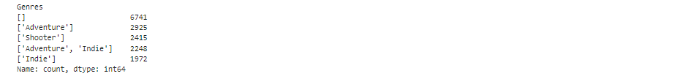

**This is the code for top 5 most popular genres:**

Pie chart for genres:

Code for Pie chart:

Number of Copies sold:

This code effectively simulates a large dataset of game backlogs based on provided statistical parameters, categorizes the data into meaningful bins, and visualizes the distribution through a pie chart. Visualization helps in understanding the frequency and proportion of different backlog categories.

This is code for number of copies sold:

